BDA400 Assignment 2

Technical Analysis using R Preliminary Stage

Student Name: Vrushabh Patel

Course: BDA400 - Data Science Tools and Techniques

GitHub Repository:
https://github.com/vrushabhpatel8597-ai/TechnicalAnalysis

1) GitHub Account and Repository Setup :
GitHub was used to create a public repository named TechnicalAnalysis for storing the files for this assignment. The repository was created successfully and a README file was added. The repository will contain the Assignment 2 report, portfolio file, R scripts, and visualizations.
The GitHub website was opened in a web browser. The New repository option was selected, and the repository name TechnicalAnalysis was entered. Public visibility was selected so that the repository link can be shared with the professor. The README file option was enabled, and the repository was created.

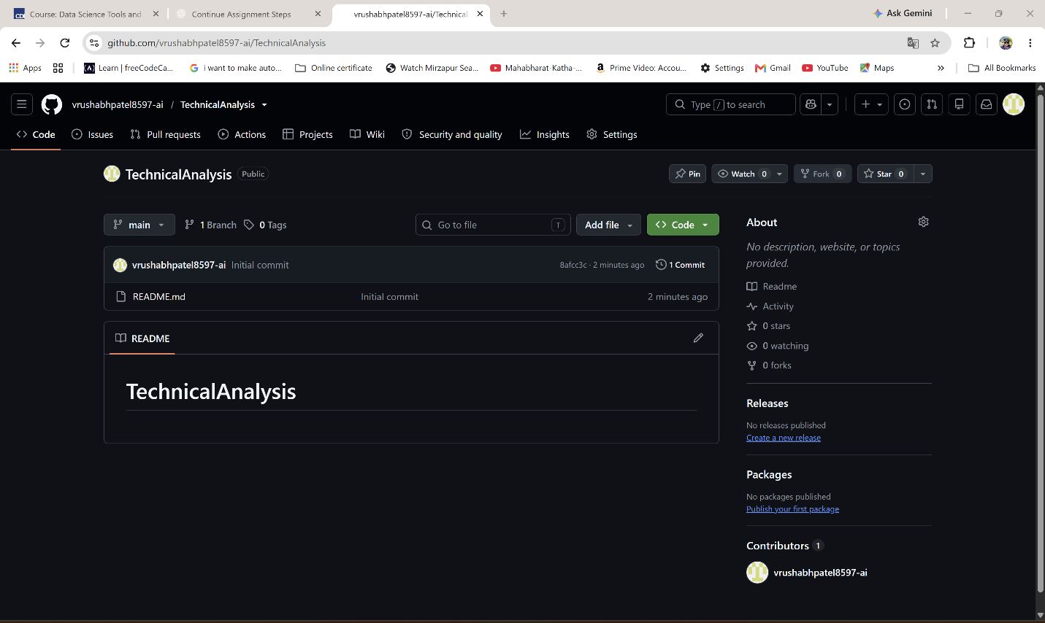
Figure 1: Public GitHub repository named TechnicalAnalysis
2) GitHub section added :
R and RStudio were installed on the Windows computer to create an environment for writing and running R code. R provides the statistical programming environment, while RStudio provides an easier interface for writing scripts, viewing output, and creating plots.

2.1 Installing R :
R was downloaded from the official CRAN website for Windows. The installer was opened and the default installation settings were accepted. After the installation was completed, R was available on the computer.
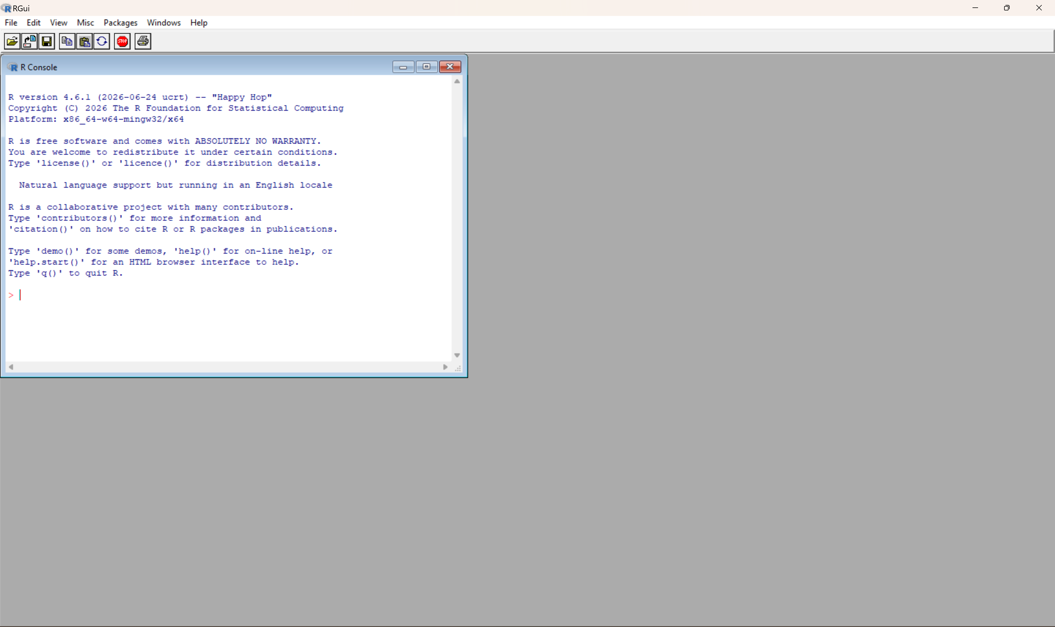
Step02 : R Installation Complete

2.2 Installing RStudio :
RStudio Desktop was downloaded from the official Posit website for Windows. The setup file was opened, the default installation options were accepted, and the installation was completed. RStudio was then opened successfully and displayed the Console panel.

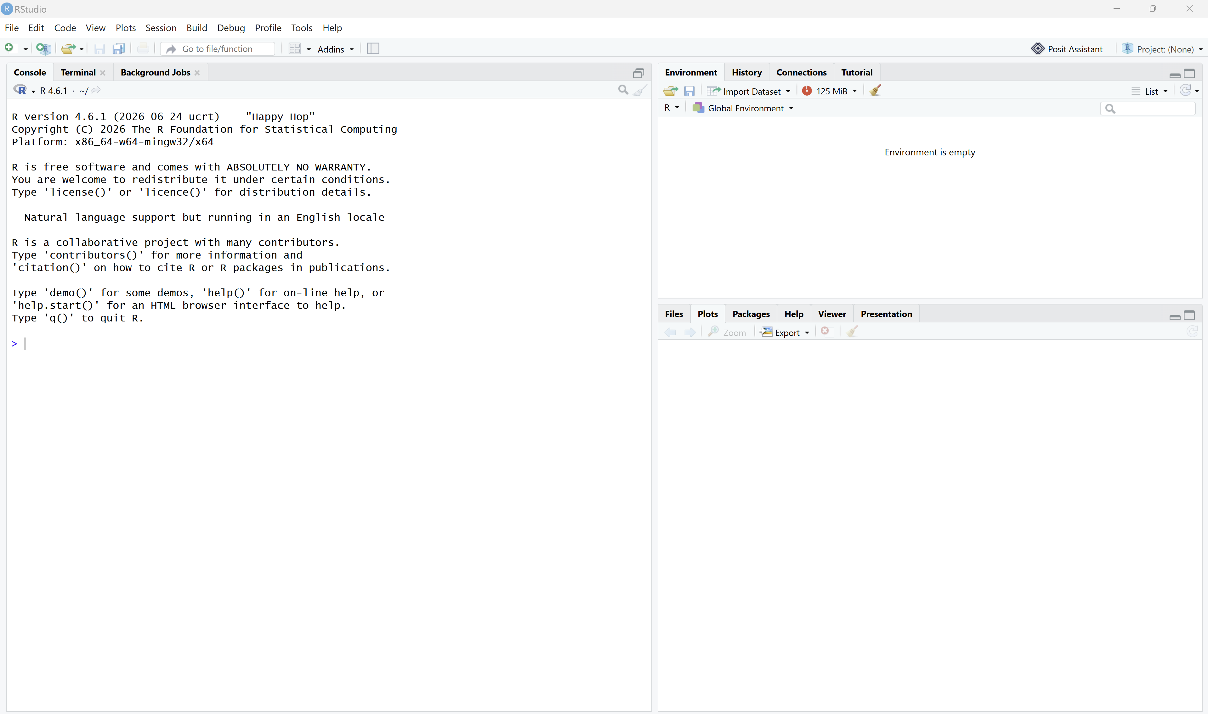
Step02: RStudio Installation Complete

3) R Packages Installation :
The quantmod and TTR packages were installed in R for technical analysis. The quantmod package was used to download stock data, while TTR was used to calculate the moving average. The required supporting packages were installed automatically by R.

3.1 Package Installation Code :
install.packages(c("quantmod", "TTR"),
repos = "https://cloud.r-project.org")
library(quantmod)
library(TTR)

3.2 Installation Result :
Both packages were loaded successfully without an installation error. The R Console returned to the prompt after the installation and loading commands were completed. The package installation warning about Rtools did not prevent the required binary packages from installing successfully.
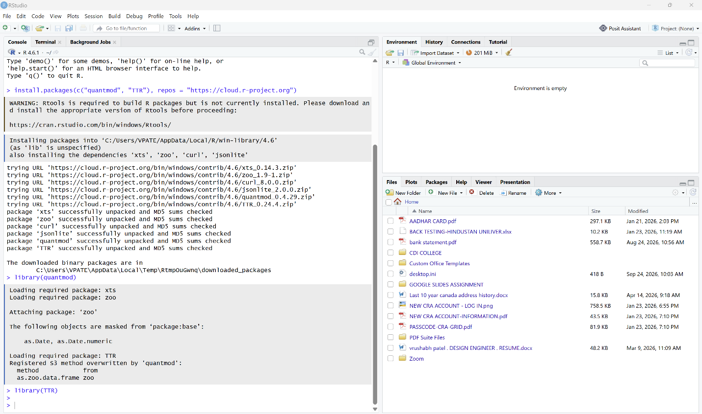
Figure 4: Successful installation and loading of the quantmod and TTR packages
4) Project Configuration and Initialization:
A text file named portfolio.txt was created inside the Assignment 2 folder. The file contains the stock symbols used for this analysis. Each symbol was written on a separate line so that the R function could read the portfolio automatically.

4.1 Stock Symbols:
The following stock symbols were added to portfolio.txt:
AAPL
MSFT
GOOGL

4.2 Portfolio File Location :
The portfolio.txt file was saved in the BDA400 Assignment 2 folder. The file was later used by the load_stock_data() function to read the stock symbols and download their historical data.
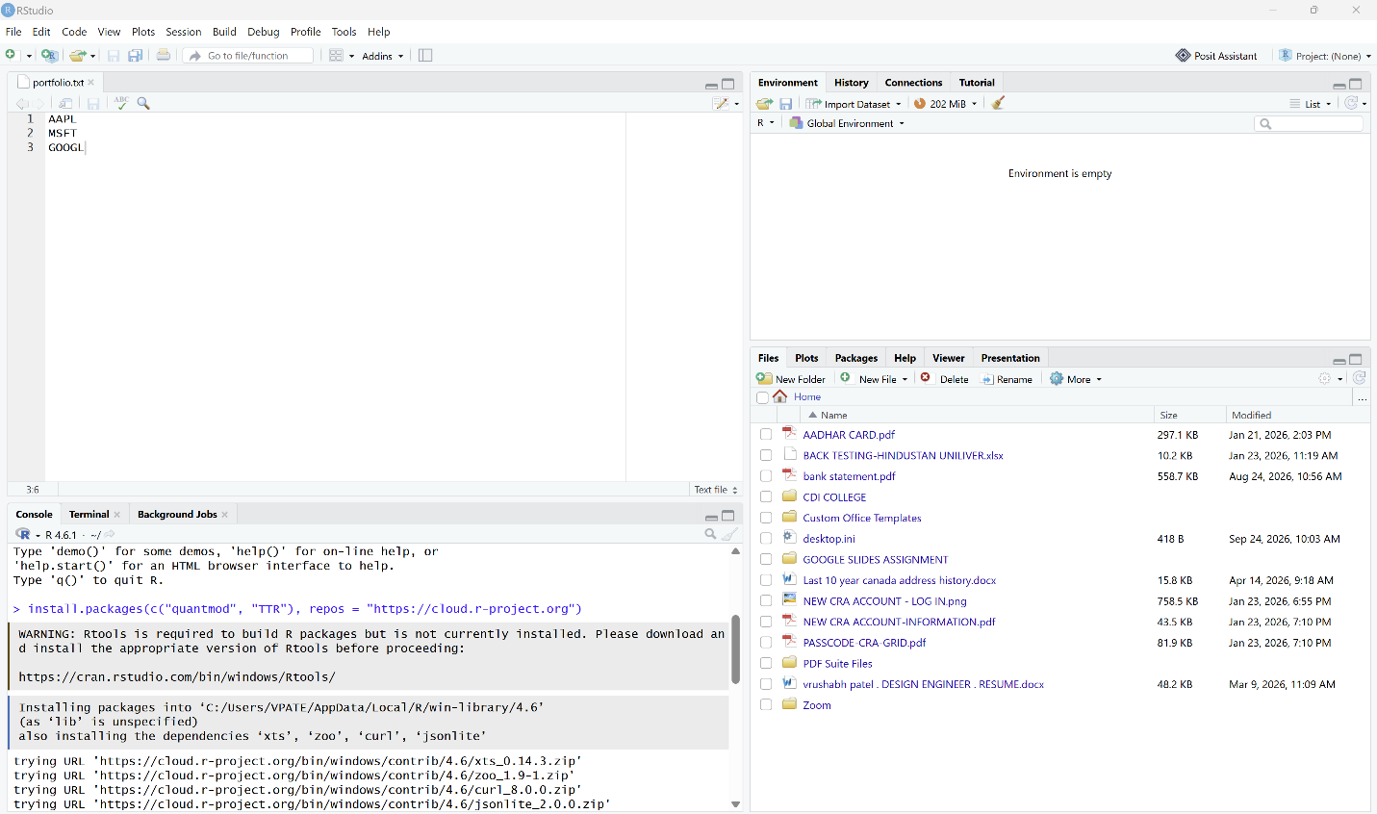
Figure 5: The portfolio.txt file containing the stock symbols

5) Function for Importing Stock Data:
The load_stock_data() function was created to read the stock symbols from portfolio.txt and download their historical data from Yahoo Finance using the quantmod package. The function stores the data for each stock as a separate data frame inside a named list.

5.1 Function Code:
library(quantmod)
load_stock_data <- function(file = "portfolio.txt") {
symbols <- readLines(file)
symbols <- trimws(symbols)
symbols <- symbols[symbols != ""]
stock_data <- list()
for (symbol in symbols) {
stock_xts <- getSymbols(
Symbols = symbol,
src = "yahoo",
auto.assign = FALSE
)
stock_data[[symbol]] <- data.frame(
Date = as.Date(index(stock_xts)),
coredata(stock_xts),
row.names = NULL
)
}
return(stock_data)
}
stock_data <- load_stock_data("portfolio.txt")
names(stock_data)
head(stock_data$AAPL)

5.2 Function Result :
The function successfully read the symbols AAPL, MSFT, and GOOGL from portfolio.txt. Historical stock data were downloaded and stored in the stock_data list. Each stock was stored separately and included the date, opening price, highest price, lowest price, closing price, volume, and adjusted closing price.
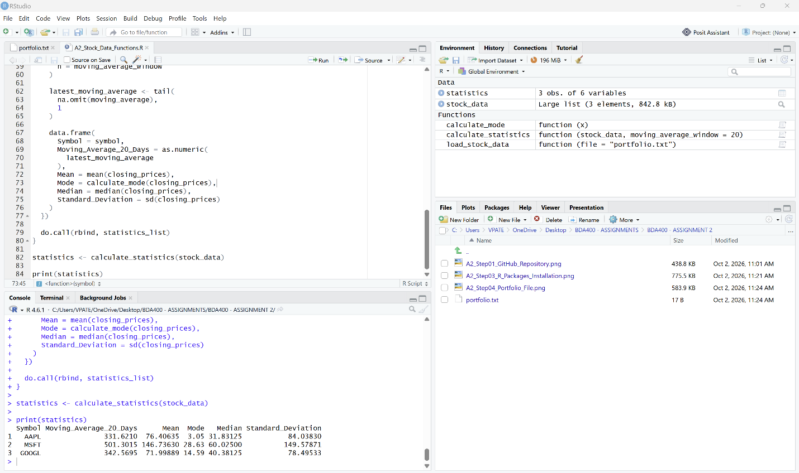
Figure 6: Stock data loaded using the load_stock_data() function.

6) Function for Computing Statistics:
The calculate_statistics() function was created to calculate basic statistics for each stock. The calculations use the daily closing prices. The function calculates a 20-day moving average, mean, mode, median, and standard deviation. The results are returned in a structured data frame.

6.1 Statistics Function Code:
calculate_mode <- function(x) {
x <- round(na.omit(x), 2)
unique_x <- unique(x)
counts <- tabulate(match(x, unique_x))
unique_x[which.max(counts)]
}
calculate_statistics <- function(stock_data,
moving_average_window = 20) {
statistics_list <- lapply(names(stock_data), function(symbol) {
stock_df <- stock_data[[symbol]]
close_column <- grep(
"\\.Close$",
names(stock_df),
value = TRUE
)[1]
closing_prices <- na.omit(stock_df[[close_column]])

moving_average <- TTR::SMA(
closing_prices,
n = moving_average_window
)
latest_moving_average <- tail(
na.omit(moving_average),
1
)
data.frame(
Symbol = symbol,
Moving_Average_20_Days = as.numeric(
latest_moving_average
),
Mean = mean(closing_prices),
Mode = calculate_mode(closing_prices),
Median = median(closing_prices),
Standard_Deviation = sd(closing_prices)
)
})
do.call(rbind, statistics_list)
}
statistics <- calculate_statistics(stock_data)
print(statistics)

6.2 Statistics Result :
The function calculated the required statistics for AAPL, MSFT, and GOOGL. The final results were displayed in a structured table. The table included the stock symbol, 20-day moving average, mean, mode, median, and standard deviation.
Figure 7: Calculated statistics for the selected stocks

7) Data Display and Visualizations :
The imported stock data were displayed using a customized display function. Line charts were also created to show the closing price and the 20-day moving average for each stock. The blue line represents the closing price, and the red line represents the 20-day moving average.

7.1 Display and Visualization Code :
source("A2_Stock_Data_Functions.R")
display_stock_data <- function(stock_data, rows = 6) {
for (symbol in names(stock_data)) {
cat("\n-----------------------------\n")
cat("Stock:", symbol, "\n")
cat("-----------------------------\n")
print(head(stock_data[[symbol]], rows))
}
}
plot_stock_data <- function(stock_data,
moving_average_window = 20) {
old_settings <- par(no.readonly = TRUE)
on.exit(par(old_settings))
par(
mfrow = c(length(stock_data), 1),
mar = c(3, 4, 3, 2)
)
for (symbol in names(stock_data)) {
stock_df <- stock_data[[symbol]]
close_column <- grep(
"\\.Close$",
names(stock_df),
value = TRUE
)[1]
closing_prices <- stock_df[[close_column]]
plot(
stock_df$Date,
closing_prices,
type = "l",
col = "steelblue",
lwd = 1.5,
main = paste(
symbol,
"Closing Price and 20-Day Moving Average"
),
xlab = "Date",
ylab = "Closing Price"
)
lines(
stock_df$Date,
TTR::SMA(
closing_prices,
n = moving_average_window
),
col = "red",
lwd = 2
)
legend(
"topleft",
legend = c(
"Closing Price",
"20-Day Moving Average"
),
col = c("steelblue", "red"),
lty = 1,
lwd = 2,
bty = "n"
)
}
}
display_stock_data(stock_data)
print(statistics)
plot_stock_data(stock_data)

7.2 Data Display and Visualization Result:
The first six rows of each stock data frame were displayed in the R Console. The statistics table was also printed. Separate line charts were created for AAPL, MSFT, and GOOGL. Each chart displayed the closing price and its 20-day moving average.
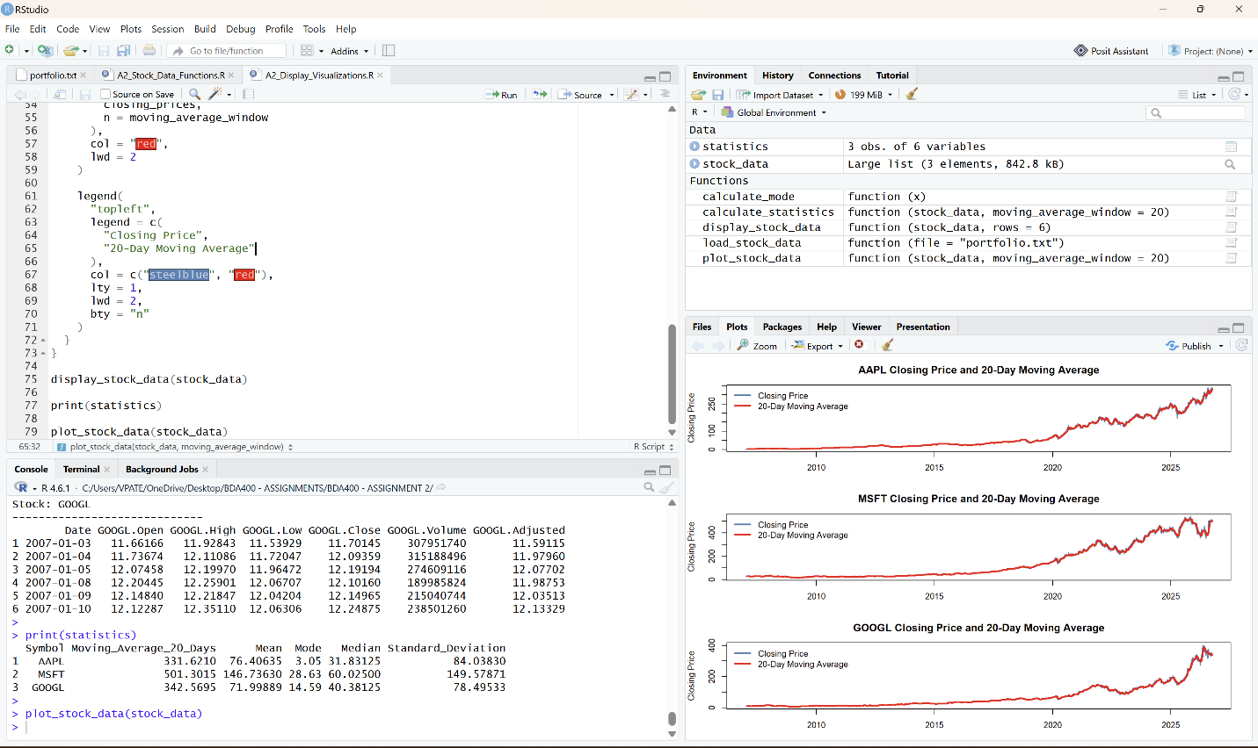
Figure 8: Stock data display and closing-price visualizations

8. Documentation and Conclusion:
This report documents the setup and preliminary technical analysis process. A public GitHub repository was created, R and RStudio were installed, the required R packages were added, and a portfolio file was prepared. Functions were created to import stock data, calculate statistics, display stock information, and create visualizations.

8.1 Files Created :
The following files were created for this assignment:
• VrushabhPatel_BDA400_A02.docx
• portfolio.txt
• A2_Stock_Data_Functions.R
• A2_Display_Visualizations.R
• A2_Step01_GitHub_Repository.png
• A2_Step02_R_Installation_Complete.png
• A2_Step02_RStudio_Installation_Complete.png
• A2_Step03_R_Packages_Installation.png
• A2_Step04_Portfolio_File.png
• A2_Step05_Load_Stock_Function.png
• A2_Step06_Statistics_Function.png
• A2_Step07_Data_Display_Visualizations.png

8.2 Conclusion :
The preliminary technical analysis environment was successfully configured. The portfolio file provided the stock symbols, and the R functions organized the imported stock data and calculated the required statistics. The data display functions and visualizations provided a clear way to examine the stock prices and moving averages. The completed files are ready to be organized in the TechnicalAnalysis GitHub repository.

